Product Specification Data Sheet
Coulter
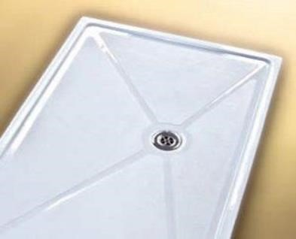
Low Access shower tray floor mounted to provide walk in access with a 35mm access profile. Can be combined with a ramp for wheelchair access. The offset waste position allows rotation of the tray to avoid joists or batons.
Sizes Available:
1200 x 700 mm
1200 X 900 mm
Supplied complete with McAlpine STW5-R trap & waste, and aluminium tiling upstand. Other trap options available from the McAlpine range. Manufactured from Glass Reinforced Plastic (GRP) with white gel coat capping and fire-retardant resin. Independently tested to withstand a weight of 100st (630kg). The resin transfer moulding (RTM) process maintains consistency of product and greatly reduces harmful fumes from being emitted into the environment. All Adaptocare trays are 95% recyclable.
The Coulter shower tray incorporates a high-performance slip resistant surface, based on a proven yacht deck pattern, independently tested in accordance with both BS7976 and UKSRG (2005) guidelines.

Please note that all Adaptocare trays are compatible with Whale pumps.
Note: Power showers are not suitable for special needs trays and wet floors.
Mixer valve showers may require a regulator should the flow rate exceed 9ltr/min.
A lifetime guarantee is extended across the full range of Adaptocare trays.

